Setting Up a new connection btwn Cosmos and Raspberry Pi

(Steps 1 and 2 only for first time setup)

On the Pi:

1)On sensors.py (under ~/Desktop/CFE/cFE-6.4.2-OSS-release/cfe/tools/flatSat/ ), update HOST ip address to the new Cosmos host address.

On the PC with Cosmos:

2)On cmd_tlm_server.txt under ~/cosmosdemo/config/tools/cmd_tlm_server add Raspberry Pi IP address: line#18: INTERFACE RPI_INT udp_interface.rb <ipaddress> 1235 5005 nil nil 128 10.0 nil ; (if using original project image on the Pi, ip=10.0.118.250)

3)To start Cosmos, under ~/cosmosdemo/ type 'ruby Launcher' and enter.

On the Pi:

4)To start the tlm/cmd system, under ~/Desktop/CFE/cFE-6.4.2-OSS-release/cfe/tools/flatSat/ type 'python3 sensors.py'. Remember that you can make of this file an executable typing 'chmod +x sensors.py', then you will be able to run typing './sensors.py'. It is just that, there is no message to be printed, just go to next step.

5)Open a second terminal tab (CTRL + SHIFT + T). Under ~/Desktop/CFE/cFE-6.4.2-OSS-release/cfe/tools/tlmUtil type python TelemetrySystem.py.

or

cFE-6.4.2-OSS-release/cfe/tools/cFS-GroundSystem/Subsystems/tlmGUI

If necessary instal pyzmq: sudo apt-get install python-zmq

Here, you also can make this file an executale file. Click on Display Page for the EventMessage service. on the new window, new commands from Cosmos should appear.

-------------------------------

The only page on our server is /var/www/html/tlm.html -> this is what you see when accessing the web server from other devices on line (the big table).

The script that creates/updates this page is generate_page.rb located at <COSMOS_FOLDER>/outputs/handbooks/

This script takes the data from flatsat_tlm.txt (this file is created by Telemetry Extractor), then formats the content into tlm.html.

Which is all possible because Extractor calls generate_page.rb.

system("ruby ~/cosmosdemo/outputs/handbooks/generate_page.rb")

progress_dialog.append_text("HTML generated!")

The telemetry data is the data from the Pi.

In summary:

On the PC with Cosmos:

0) Starts Command and Telemetry Server.

1) COSMOS send a CMD to start TLM.

Go Command Sender, put Target: RPI, Command: START_TLM and send, then put Command: ALL_TLM and send.

2) RPI start sending what was asked.

3) COSMOS is saving it as logs.

3.5) Start apache: sudo service apache2 start

4) COSMOS extracts the TLM from log into text format, using Telemetry Extractor following the pattern of this picture:

4.5) Ignore the exception that will appear.

Steps 5, 6, 7 and 8 are automatically done when step 4 is completed.

5) COSMOS calls GENERATE_PAGE.

6) GENERATE_PAGE creates TLM.HTML

7) TLM.HTML auto refresh itself to ensure that it i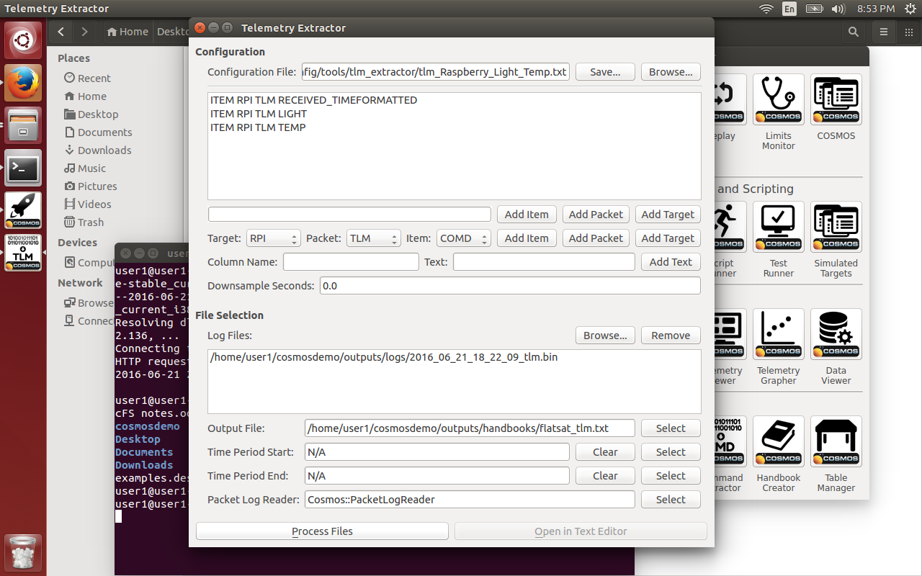s up-to-date for every user.

8) APACHE make it accessible to all network users.

9) Open browser and go to localhost/tlm.html

There is one problem here, step 4 is not automatically done by Cosmos. So someone has to press the PROCESS FILES button in the extract window in order to go to next step.

PS:

It would be great if step 4 was done in an 'autonomous fashion.' I guess you can add this to the tlm_extractor code (as we did with the generate_page call but now it would be done every few minutes or so).